HOBBY APP

Aim:  
 To create an engaging and interactive platform that helps users explore and pursue various hobbies by providing essential information, materials, and inspiration.

Procedure:

STEP 1: Create frames for each screen in the app, matching the dimensions for iPhone 14 & 15 Pro Max.

STEP 2: Design the onboarding screen with an illustration and "Get Started" button.

STEP 3: Create the hobby selection screen with buttons representing different hobbies.

STEP 4: Design detailed screens for each hobby, including required items and informational sections.

STEP 5: Add navigation elements, such as back buttons, and link screens for smooth flow in the prototype..

Prototype:

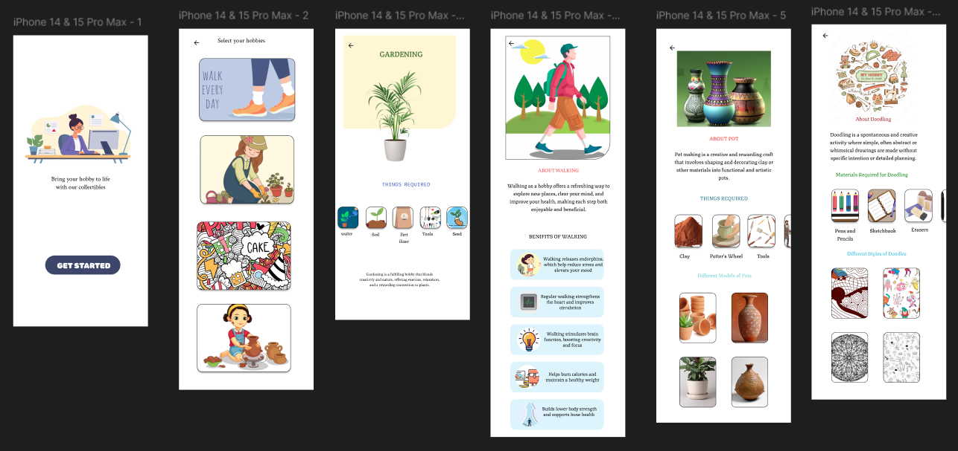

Result:  
A user-friendly mobile app that allows users to discover hobbies, learn about the required tools and materials, and explore different activities through a visually appealing and informative interface.